

Name Shehryar

Roll No Bsf2000745

Class BS IT Evening

Semester Fourth

Subject Database system

Course code COMP2114

Teacher Name Dr. Danish



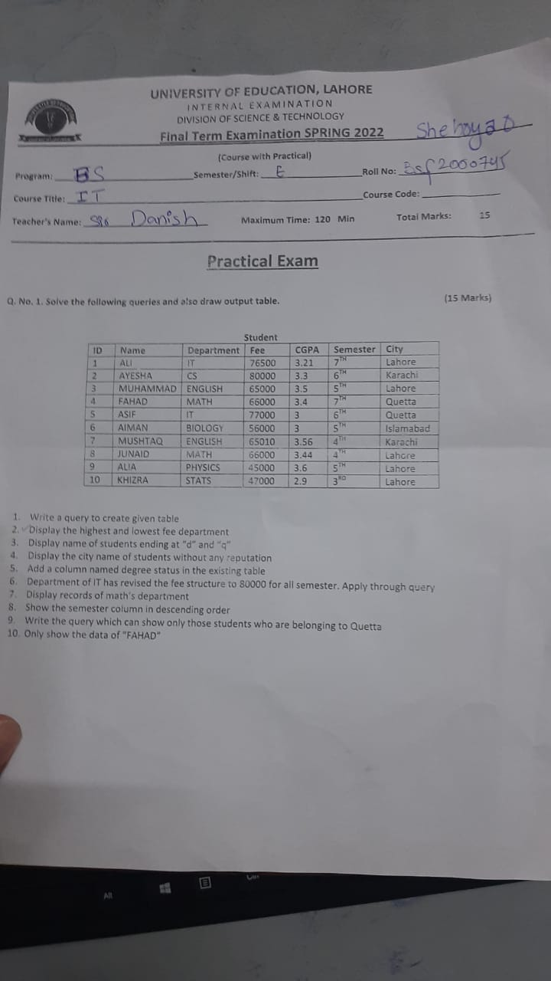

**Question No 1:**

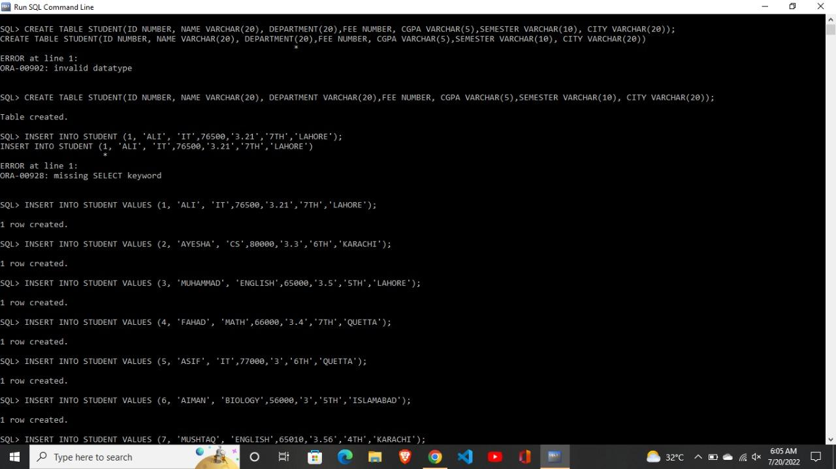Write a query to create a given table

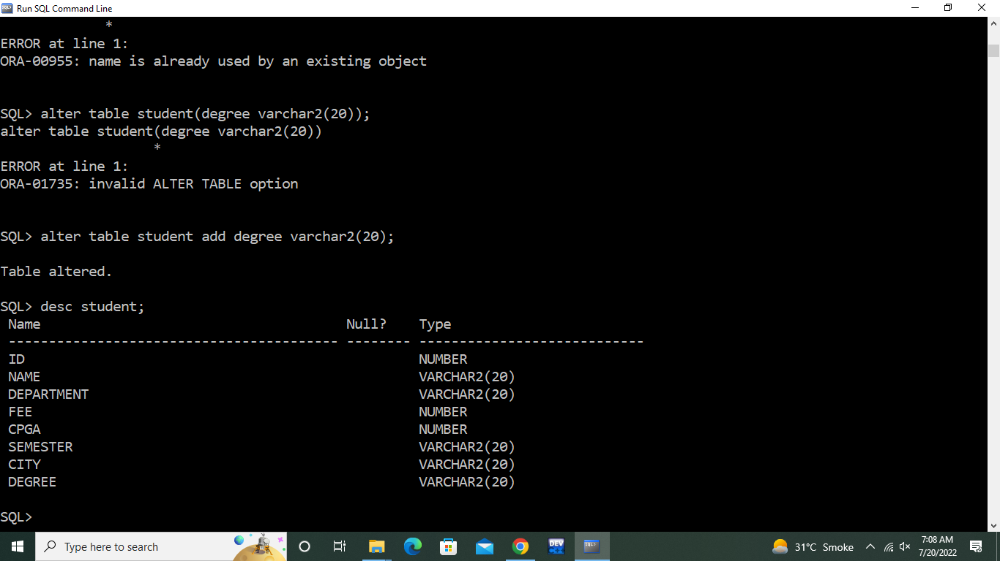

**Question No 2:**

Display the highest and lowest fee department

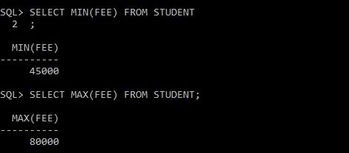

**Question No 3:**

Display the names of students ending at "d" and "q".

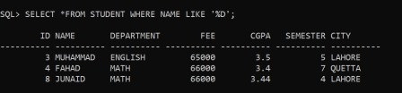

**Question No 4:**

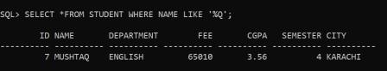Display the city name of students without any reputation.

**Question No 5:**

Add a column named "degree status" in the existing table.



**Question No 6:**

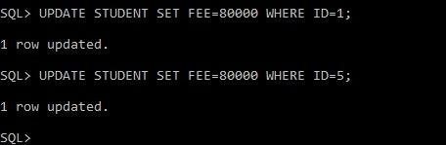Department of IT has revised the fee structure to 80000 for all semesters. Apply through a query

**Question No 7:**

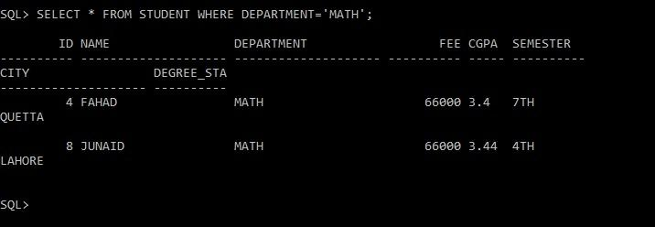Display records of math department

**Question No 8:**

Show the semester column in descending order.

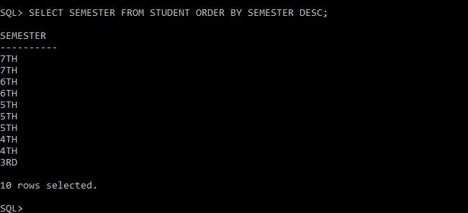

**Question No 9:**

**Write the** query which can show only those students who belong to Quetta

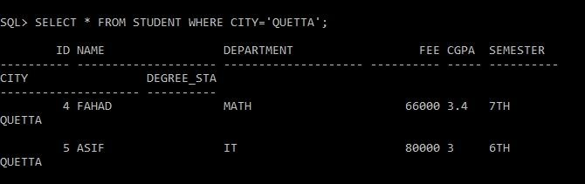

**Question No 10:**

Show the data for "FAHAD"

